NMSU Youth Sports Camp

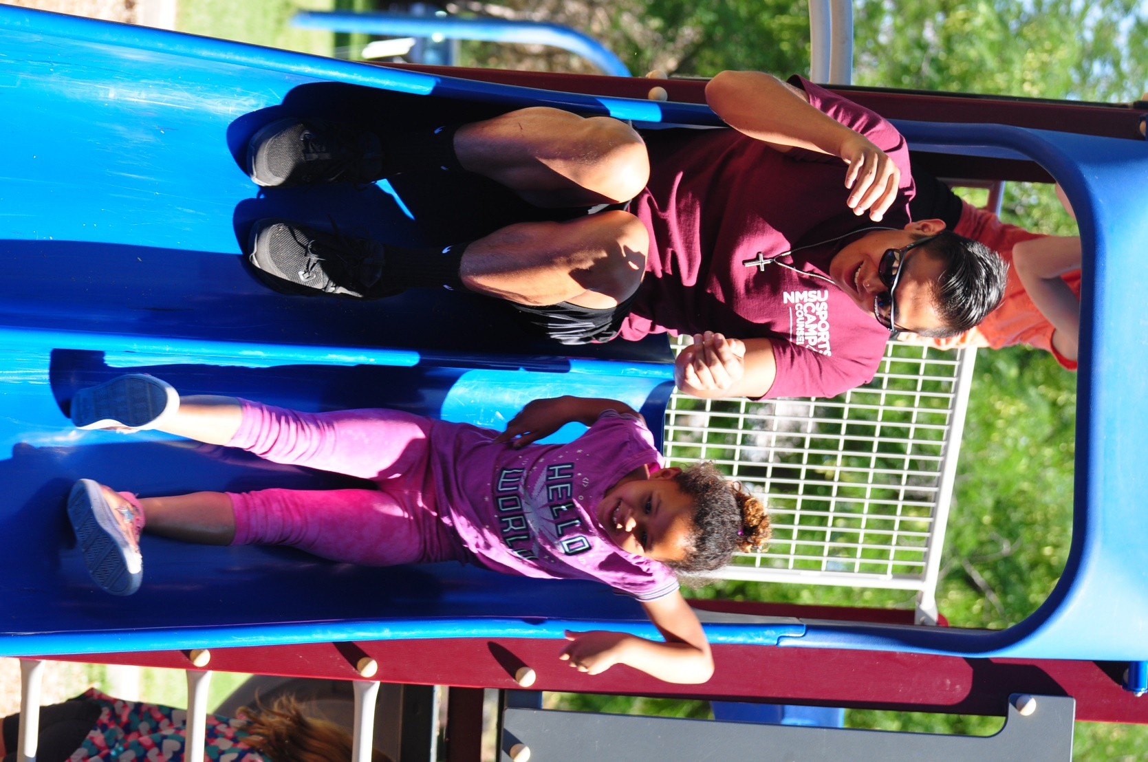

Camper’s Field Guide

2020

Contents

GET READY FOR AN ADVENTURE! 3

Mission Statement 3

Camp Registration 3

Sessions and Fees 3

Refund/Transfer Policies 3

Information for Parents and/or Guardians 4

Parent/Guardian’s Night 4

Sports Camp Structure 4

What to Bring for Camp 4

What to Leave at Home 4

Daily Check-In/Check Out 5

Pre-Camp and Post-Camp 5

Late Camper Arrivals 5

Early Dismissal 5

Please Note: 5

Camper Expectations 6

Qualifying Skills 6

Behavior and Conflicts 6

Discipline 6

Illnesses and Injuries 7

Medication 7

Confidentiality 7

Reporting Suspected Abuse or Neglect 7

Questions or Concerns 8

Camp Questions 8

Registration Questions 8

Facility Questions 8

APPENDIX A: NMSU Youth Sports Camp General Schedule 9

APPENDIX B: NMSU Youth Sports Camp Age-Specific Schedules 10

APPENDIX C: NMSU Youth Sports Camp Area Map 11

# GET READY FOR AN ADVENTURE!

The NMSU Youth Sports Camp Staff is excited to have you with us! We hope that your Camper is ready for a week of games, smiles, and fun. We have prepared this Field Guide to better prepare Campers for their Session with us, please read through it completely with your Camper prior to their first day.

# Mission Statement

The NMSU RecSports Youth Sports Camp provides an engaging sports and development experience for children ages 5-12. The Camp develops a wide variety of fundamental physical activity skills that are inherent to a healthy lifestyle and a lifetime of physical fitness. This is accomplished through 7 week-long Sessions where Campers will engage in indoor and outdoor age-appropriate activities.

# Camp Registration

Applications and payment are due the **WEDNESDAY** be­fore each Session begins; one Application per Camper is required. A complete Application consists of:

* Sports Camp 2020 Registration Application Card
* Signed Informed Consent and Assumption of Risk Form
* Signed Medical Consent and Treatment Authorization Form
* Signed Code of Conduct Form
* Relevant Payment

Cash, check (made payable to NMSU RecSports), and all major credit cards are accepted. Payment and registration can be made at the NMSU Activity Center, Rm.101.

# Sessions and Fees

**Monday** – **Friday** 8:45am – 3:15pm

Pre-Camp: 7:30 - 8:45am ($55)

Post-Camp: 3:15 - 5:45pm ($80)

Session 1 June 15-19 ($175)

Session 2 June 22-26 ($175)

Session 3 June 29- July 2 ($140)

Session 4 July 6-10 ($175)

Session 5 July 13-17 ($175)

Session 6 July 20-24 ($175)

Session 7 July 27-31 ($175)

*Session 3 is only 4 days in observance of July 4th.

## Refund/Transfer Policies

Refunds, in full or in part, will only be given to indi­viduals who have provided documentation of a medical circumstance that hinders participation. Full refunds will only be given if the Director has received notification prior to the beginning of the Session. Partial refunds will be given if a medial circumstance occurs dur­ing the Session and will be based on the number of days missed.

Extenuating circumstances will be considered for non-medical refund requests.

# Information for Parents and/or Guardians

## Parent/Guardian’s Night

On the Saturday night before each Session, at 4pm – 5pm in the Main Gym of the NMSU Activity Center, there will be a “Meet the Counselors and Tour the Camp” night. Parents/Guardians and Campers from all Sessions are encouraged to attend. This is a great opportunity to get to know the Director and Counselors that your Camper(s) will be spending the week with, and to address any immediate concerns. Parents/Guardians and Campers will also have the opportunity to tour the facilities and see what a day in the life of a Camper will look like.

## Sports Camp Structure

Programs for 5-8 year-olds will focus on developing gross fundamental motor skills and pro-social behavior that set the stage for success in personal and sports performance later in life through lead-up games, coordination-focused games, and traditional and non-traditional physical activities.

Programs for 9-12 year-olds will focus on developing fine motor skills as well as beginning instruction on developing skills necessary to participate in specific sports such as softball, soccer, volleyball, badminton, football, basketball, floor hockey, ultimate Frisbee, swimming and cooperative games. Positive competition is introduced, and individual leadership is used.

*See Appendices A & B for a more detailed schedule for your Camper’s Age*

## What to Bring for Camp

* A backpack and a water bottle, labeled with the Camper’s name. There are water fountains available if you do not have a bottle for your Camper.
* This is an activity-based Camp, so please dress your Camper(s) in athletic summer attire: shorts/pants, light weighted shirts, socks, and athletic shoes.
* Campers will need to pack an appropriate swimsuit, flip flops, and a towel every day. Sunscreen and safety flotation devices will be provided when necessary. We have LOTS of pool toys!
* 5-6 year old Campers will need to bring a snack, as they have snack time each day. If you forget to provide one, your Camper will be offered fresh fruit from the Taos cafeteria.
* Any required food items for lunch that your Camper prefers. Some Campers have restrictive diets, and while the Taos cafeteria has many options, your Camper might not want to eat them.
* During Pre- and Post-Camp it sometimes gets cold in the Gym, so pack a light jacket if you Camper gets chilly.
* Have your Camper wear their Youth Sports Camp t-shirt (given on Monday) on Friday for Age Group photos! We will post Age Groups to the Facebook NMSU RecSports page:

https://www.facebook.com/NmsuRecSports/

## What to Leave at Home

* Toys, games, or personal items. These items are distracting from the Camp, and often become sources of conflict between Campers.
* Money. There is nothing your Camper is able to purchase at Camp.
* Electronic Devices. If you require your Camper to have a cell phone, it must be arranged with Staff, and be secured in their backpack.
* NMSU Youth Sports Camp **WILL NOT** be held responsible for any lost, stolen or damaged items.

# Daily Check-In/Check Out

Each day, your Camper(s) must be signed in and out by a Parent/Guardian. Parents/Guardians are encouraged to introduce themselves to the Counselors, and to ask any questions they or their Camper(s) have. A positive rapport among Parents/Guardians and Camp Staff encourages Campers’ behavior and helps them feel comfortable in a new environment.

Check-In and Check-Out will occur in the Activity Center Parking Lot, directly across from the Activity Center for Campers that do not stay for Post-Camp. There will be Staff on hand to greet and receive your Camper(s).

*See Appendix C for a Map of NMSU Sports Camp Area and Drop-Off/Pick-Up Location*

## Pre-Camp and Post-Camp

Camp Staff will be available for Campers during Pre- and Post-Camp activities from 7:30am – 8:45am and 3:15 - 5:45pm. There is a flat rate regardless if a Camper stays the entire time. Counselors will engage your Camper with additional activities, or allow them free-time.

* Campers **CANNOT** be brought to for regular Camp hours.
* Parents/Guardians who pick up Camper(s) after 5:45 p.m. will be charged a $15 fee for the first 15 minutes; thereafter, they will be charged $2 per minute.

**Please note:**

At any time, you may add or remove Authorized Persons for your Camper by providing their legal names, in writing, to the AggieFit Office or to the Camp Director. Sports Camp Staff is not responsible for communicating Camper pick-up among any authorized adults. The responsibility remains among those individuals.

Without authorization from the Parent/Guardian, we **cannot** allow any person not formally identified to pick up your Camper(s), nor can we deny an authorized person the same.

## Late Camper Arrivals

If you arrive late to Camp, your Camper(s) still must be signed in by a Parent/Guardian. You must bring your Camper(s) inside the Activity Center and deliver them to their respective Age Group. Staff at the front desk will be able to assist you with this.

## Early Dismissal

For accountability purposes, Parents/Guardians are required to inform the Camp Director any time a Camper will be picked up early, even if they are returning later. The Camp Director will arrange for your Camper to be ready at the required time, and deliver them to you.

**Please Note:**

Please allocate at least 15-20 minutes for the early pick up process.

# Camper Expectations

## Qualifying Skills

The following competencies are necessary for successful Camp participation. All Campers must be able to demonstrate the following behaviors with minimal to no assistance:

* Separate from their Parent/Guardian
* Actively participate in a full-day Camp
* Follow and accept directions and structure
* Take turns, share, and cooperate with their Age Group
* Ability to communicate their needs to Staff and fellow Campers
* Respect others and their property
* Be able to dress themselves and use the restroom independently

## Behavior and Conflicts

Meeting new people and making new friends is an exciting time for our Campers and Counselors alike, whether this is their First day at Camp, or their Tenth. Our goal is to provide each Camper with the activities, situations, and skills necessary to positively interact with their Age Group and resolve conflicts in a manner that is appropriate and with regard to other Campers’ feelings. We seek cooperative and effective solutions by using the following techniques:

* Establish Mutual Respect
* Teach Ground Rules
* Clarify Expectations
* Display a Positive Role Model
* Be Consistent
* Offer Realistic Choices
* Provide Encouragement
* Encourage Problem Solving
* Offer Assistance
* Be Willing To Start Over

## Discipline

At NMSU Youth Sports Camp, our intent is not to punish negative actions and behaviors, but to promote positive ones. Disciplinary action, when required, will be documented and forwarded to the Parent/Guardian, and the Camp Director will work with them to promote positive behavior to ensure you Camper has the best possible experience at NMSU.

Depending on the severity and frequency of the offense, Staff will take the following steps:

1. Ensure Understanding: Counselors will discuss what the appropriate behavior with the Camper(s) is, and ensure clarity of expectations.
2. “Time-Out” to Re-Focus, where the Camper will be set aside, in a safe place, away from the Age Group. Expectations will be readdressed, and a plan of action will be discussed.
3. 1-Day Suspension. Camper will be required to leave Camp for the day, a plan of action will be discussed with the Parents/Guardians, and the Camper is welcome back the next day.
4. Dismissal from Camp. Campers dismissed from Camp for disciplinary reasons will not be allowed to return for the remainder of the summer.

**NOTE:** Refunds, in full or part, will not be given for Suspensions and Dismissals from Camp.

# Illnesses and Injuries

The NMSU Sports Camp does not have the accommodations necessary to provide care for Campers who are ill or previously injured. Please do not send your Camper(s) if they are not well enough to participate in all Camp activities. For everyone’s safety and well-being, we cannot allow Campers with contagious or communicable disease to attend Camp.

Please keep your Camper(s) at home if any of the following symptoms develop:

* Diarrhea
* Fever of 100 degrees or above
* Severe coughing
* Unusual spots or rashes
* Difficult or rapid breathing
* Sore throat/trouble swallowing
* Infected skin patches
* Tears, redness of eyelids with discharge
* Headache and/or stiff neck
* Mouth sores
* Vomiting
* Severe itching of body or scalp
* Severe cuts or open sores

Camper(s) must be free of symptoms for **24** hours, or have a physician’s authorization, in order to participate at Camp.

If your Camper becomes ill or injured during Sports Camp, we will administer First Aid and contact the listed Parent/Guardian and Emergency Contact immediately. We ask that you pick up your Camper(s) promptly to best determine their medical needs.

In the event of a serious illness or accident, we will administer first aid and call EMS, and your Camper(s) will be transported to the nearest hospital. You will be notified of the injury, the EMS agency, and the medical facility your Camper is being treated at.

## Medication

If possible, please try to schedule doses while the Camper is home. Medication must be given to the Camp Director – Camper(s) may not carry their own medication. Rescue medications will be kept by the Counselor assigned to your Campers’ Age Group.

## Confidentiality

The NMSU Sports Camp respects the rights of each family to privacy and confidentiality regarding health, behavioral, and developmental records and information concerning their Camper(s). The practice of maintaining the confidentiality of verbal information and written records is a basic ethical policy at NMSU, and suspected infractions will be addressed immediately.

## Reporting Suspected Abuse or Neglect

NMSU Employees who suspect a Camper is a victim of abuse/neglect are legally required to report the matter immediately to the Camp Director. The Director shall document, in writing, all facts of the situation. The Director will report all facts to the Department of Social Services and relevant law enforcement, and when appropriate, inform the Parent/Guardian.

# Questions or Concerns

**Camp Questions or Concerns**

A healthy relationship between Camp Staff, the Camper, and the Parents/Guardians is necessary to fully empower your Camper to succeed at Camp, and also have fun! The Camp Director has an open-door policy for any questions, comments, or concerns that may arise during a Session. Daily Drop-Off and Pick-Up is usually the most convenient times to have these conversations, and the Camp Director will make every effort to speak with you privately, or at another time, when needed.

**Camp Director: Anthony McGlone**  **575-646-5150**

**antmcg79@nmsu.edu**

**Registration Questions**

Life consistently throws us curves, and we want to make sure your Camp experience is the best possible for your Camper. If you ever have any registration needs, questions, or scheduling issues, please contact the AggieFit Office.

**NMSU Aggie Fit Office** **575-646-2907**

**aggiefit@nmsu.edu**

**Facility Questions**

Southern New Mexico experiences heavy rains and severe storms during the summer, and there is always at least one soggy day at Camp. In the event of inclement weather, an email will be sent to the Parent/Guardian with information. If you do not receive one, please contact the NMSU Activity Center for information about Camp that day. We have yet to cancel a day of Camp due to weather, but have modified Drop-Off/Pick-Up locations and activities due to flooding and lightening. At the very least we will ask you to bring an extra pair of socks for your Camper.

**NMSU Activity Center Front Desk** **575-646-2885**

# APPENDIX A: NMSU Youth Sports Camp General Schedule

# 

# APPENDIX B: NMSU Youth Sports Camp Age-Specific Schedules

**Age: 5-6**

9:15 – 10:00: Rock Climbing

10:00 – 10:45: Group Activity or Park

10:45 – 11:45: Lunch

11:45 – 12:45: Group Activity

12:45 – 1:45: Pool

1:45 – 2:45: Snack Time/Free Time

**Age: 7-8**

9:15 – 10:00: Group Activity or Park

10:00 – 10:45: Rock Climbing

10:45 – 11:45: Group Activity

11:45 – 12:45: Lunch

12:45 – 1:45: Low Intensity Activity

1:45 – 2:45: Pool

**Age: 9-10**

9:15 – 10:00: Group Activity

10:00 – 10:45: Intramural or Group Activity

10:45 – 11:45: Rock Climbing

11:45 – 12:45: Lunch

12:45 – 1:45: Low Intensity Activity

1:45 – 2:45: Pool

**Age: 11-12**

9:15 – 10:00: Group Activity

10:00 – 10:45: Intramural or Group Activity

10:45 – 11:45: Lunch

11:45 – 12:45: Rock Climbing

12:45 – 1:45: Pool

1:45 – 2:45: Free Time or Group Activity

# APPENDIX C: NMSU Youth Sports Camp Area Map

