The NMSU Outdoor Leadership Program (OLP) prepares students to plan, implement and lead outdoor recreation and/or cultural activities for the NMSU student body. Each Fall semester, the OLP seeks highly motivated students who want to enrich their college experience by increasing their leadership skill sets. Participants receive training in group dynamics, teaching techniques, risk management, wilderness first aid, sustainable ethics, and outdoor skill sets such as backpacking and rock climbing. The OLP equips its students with practical leadership experiences to complement their academic degrees and give them the edge in the job market after graduation.

Eligibility Requirements:
The Outdoor Leadership Program is physically, mentally, and emotionally demanding. In order to participate in the program, participants must acknowledge and meet the following Eligibility Requirements.
- Current NMSU main campus undergraduate or graduate student in good standing with two semesters or more left for completion of graduation requirements.
- Maintain a cumulative 2.5 GPA or above.
- Maintain full time student status during Fall and Spring semesters.
- Must possess a valid and violation free driver's license.
- Lift, balance, and carry personal and group equipment between 35-50lbs.
- Interest in outdoor activities.
- Desire to learn how to teach, lead, supervise, and provide fun and meaningful activities for the NMSU student body on campus and in outdoor environments.
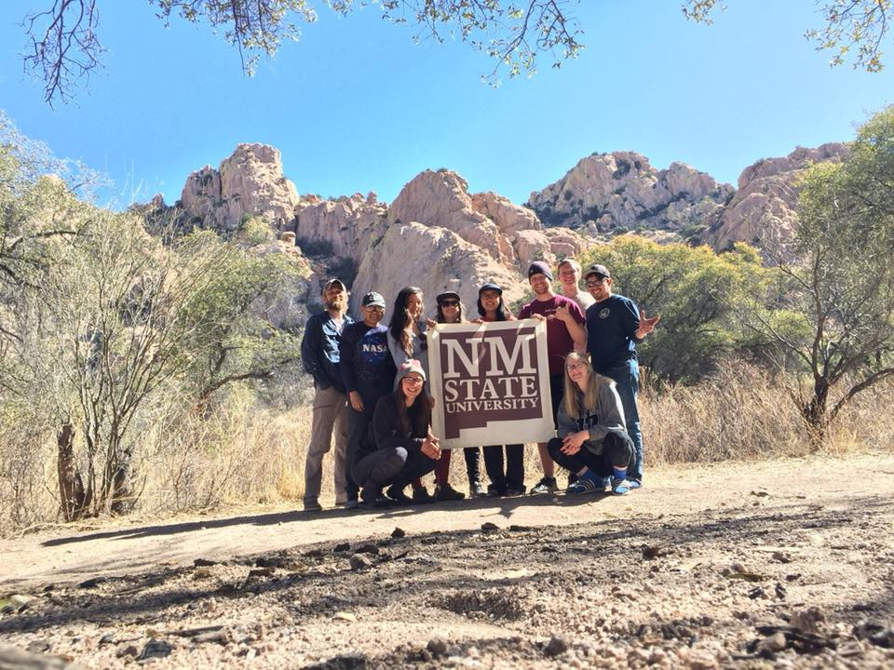
Applications Must Include:
- OLP Application Form
- Letter of Interest
- Resume

Optional Information Meeting:
August 22, 23, and 26 @ 5:30pm
In the Otero Rm (129) of Corbett Center Student Union.

Training Structure
All selected applicants enter the Outdoor Leadership Program as a Technician, and will be invited to attend a mandatory Orientation Trip scheduled for September 21-22, 2019.
At a minimum, all Technicians must complete the following requirements prior to becoming a lead facilitator and leading trips on their own:
- Wilderness and Remote First Aid and Adult CPR/AED
- NMSU Defensive Driving
- Leadership and Facilitation Class
- Low Ropes Course Facilitation
- Successfully design and implement an outdoor trip as a Lead Facilitator
Those interested in leading backpacking or climbing trips will have to attend additional skill specific trainings.

All Trainings are conducted as one day or two day overnight trainings during the weekends with the exception of Defensive Driving. Program participants have the option of completing their required trainings through the duration of multiple semesters. All trainings are held each semester so students can plan accordingly. Accepted applicants must actively participate in the trainings and program meetings each semester to remain in the program.

Benefits of the Outdoor Leadership Program
Community: Becoming a trip leader is becoming part of a family. Leaders run trips together, work, hang out, and have fun together.
Discovery: Trip leaders have an opportunity to introduce students to the great outdoors, bringing people where they have never been before and see their discovery. You’ll help people push boundaries, feel better about themselves, and find new and healthy ways to have fun.
Education: Your technical and interpersonal will develop through trainings and your proficiency at leading others will increase
Leadership: Leading trips provides tons of practical real world experience that will benefit any career path. It develops self-confidence, leadership, logistics and communication skills, teaching skills, and problem solving. Every trip can teach you something new about yourself and how you work with others.
Purchases/Rentals/Employment: As an OLP member, you receive free rentals from our Outdoor Center, and a 30% discount on purchases.

Please submit the following documents with this application form by September 6, 2019, by 5pm, at NMSU Activity Center Room 235, or email them to antmcg79@nmsu.edu

- Cover Letter
- Resume
- Students will be contacted for an interview

Applicant Information
Name: __________________________________________________________________________
Current Address: ________________________________________ City: _____________________ State: _________ Zip: ______________ Phone: _________________________________________
NMSU Email: _______ __________________________ Aggie ID: ___________________________

Education
Year in School: _______________________ Expected Graduation Date: ______________________
Major: ________________________________________ GPA: ______________________________

Current Certifications, Experience, or Relevant Coursework 1._______________________________________________________________________________
2._______________________________________________________________________________
3._______________________________________________________________________________
4._______________________________________________________________________________

Additional Background Information

Why are you interested in participating in the Outdoor Leadership Program?

Share any experiences personal or professional experiences that you believe relate to this program.

Explain what you would expect to gain from the program and how it will benefit you as an individual, or your community.

